Q.1 Create group and user as given below

Red

apple

banana

cat

dog

elephant

Blue

fish

gun

horse

icecream

green

jelly

kitkat

lolipop

marshmallow

orange

new

oppo

vivo

china

a. create directory named EVERYONE in /home. Give all permission to EVERYONE

b. Create a file with every user (whoami >> username.txt)

oppo -> primary group change -> one

vivo -> primary group change -> two

jelly,kitkat, lolipop, marshmallow -> add these users to sudo group

fish,gun -> add these users to one group as well (secondary group)

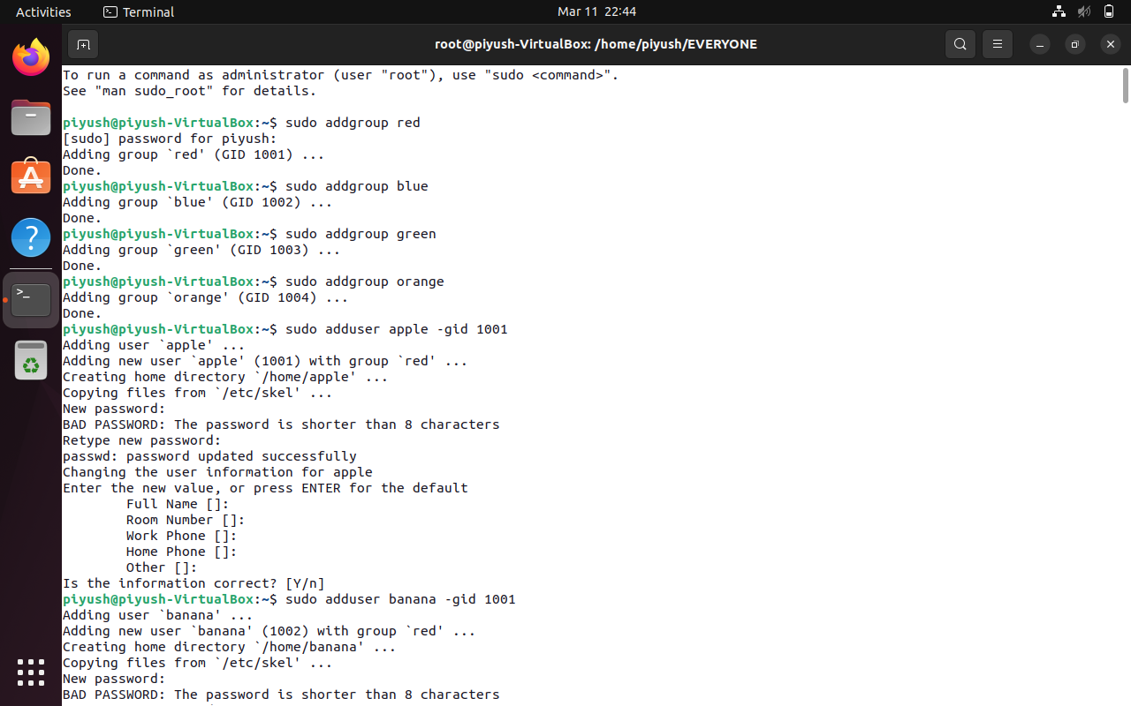

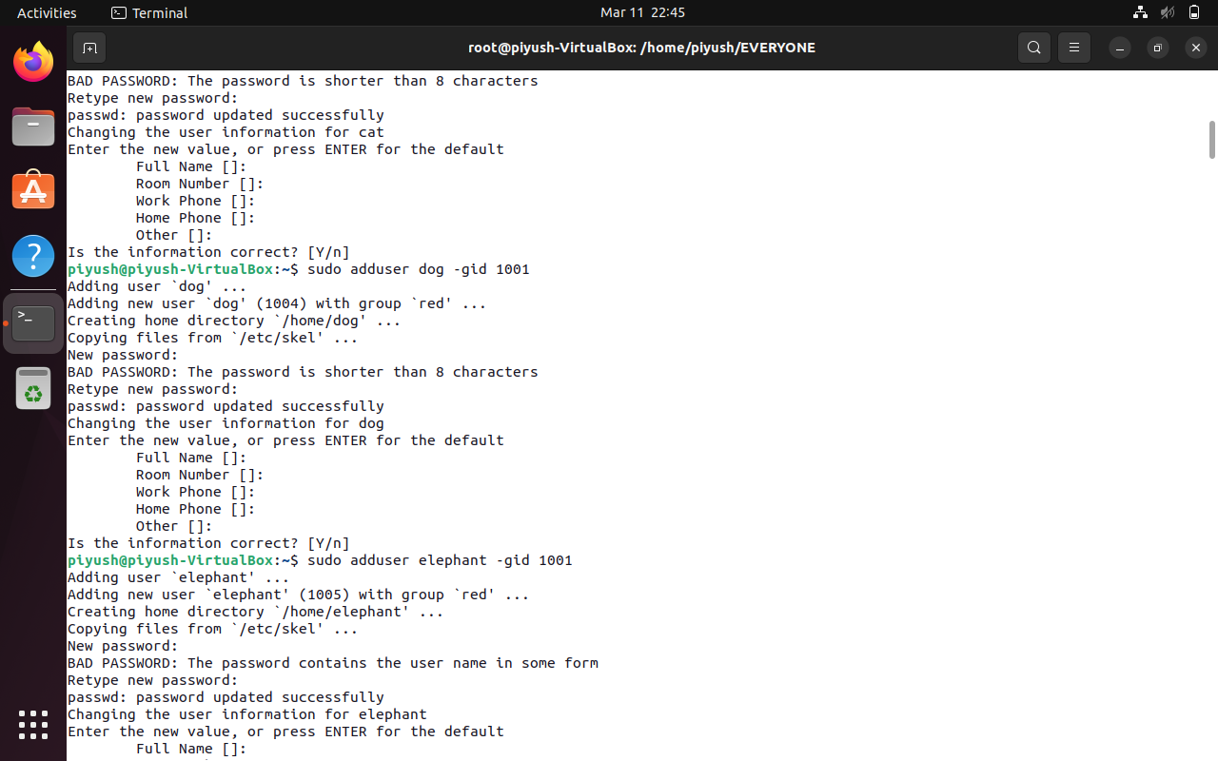

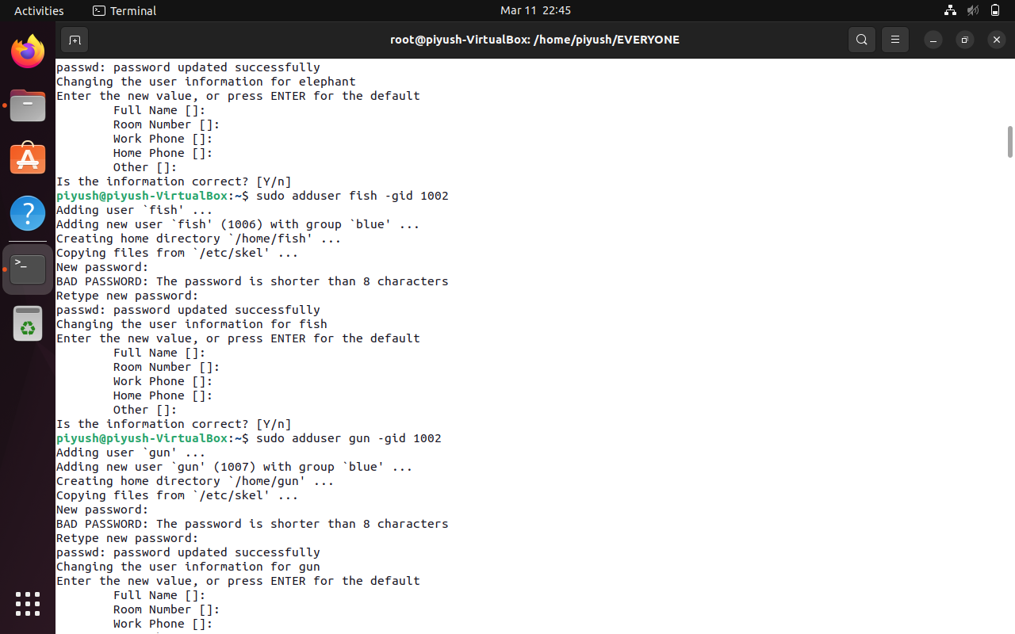

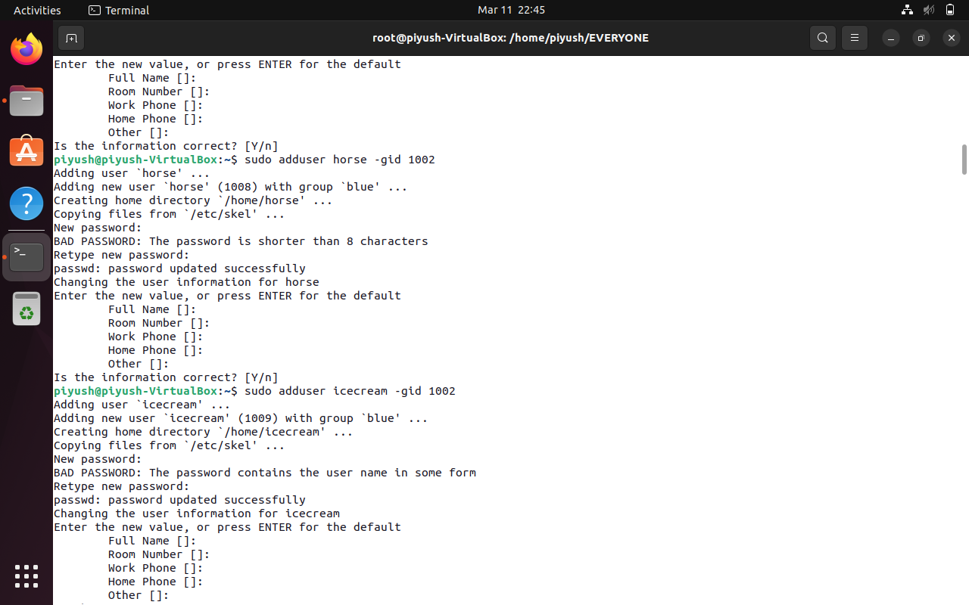

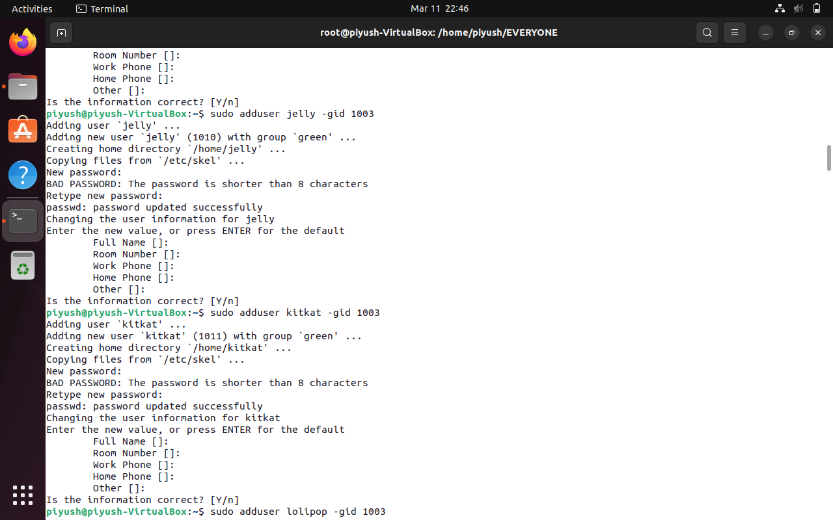

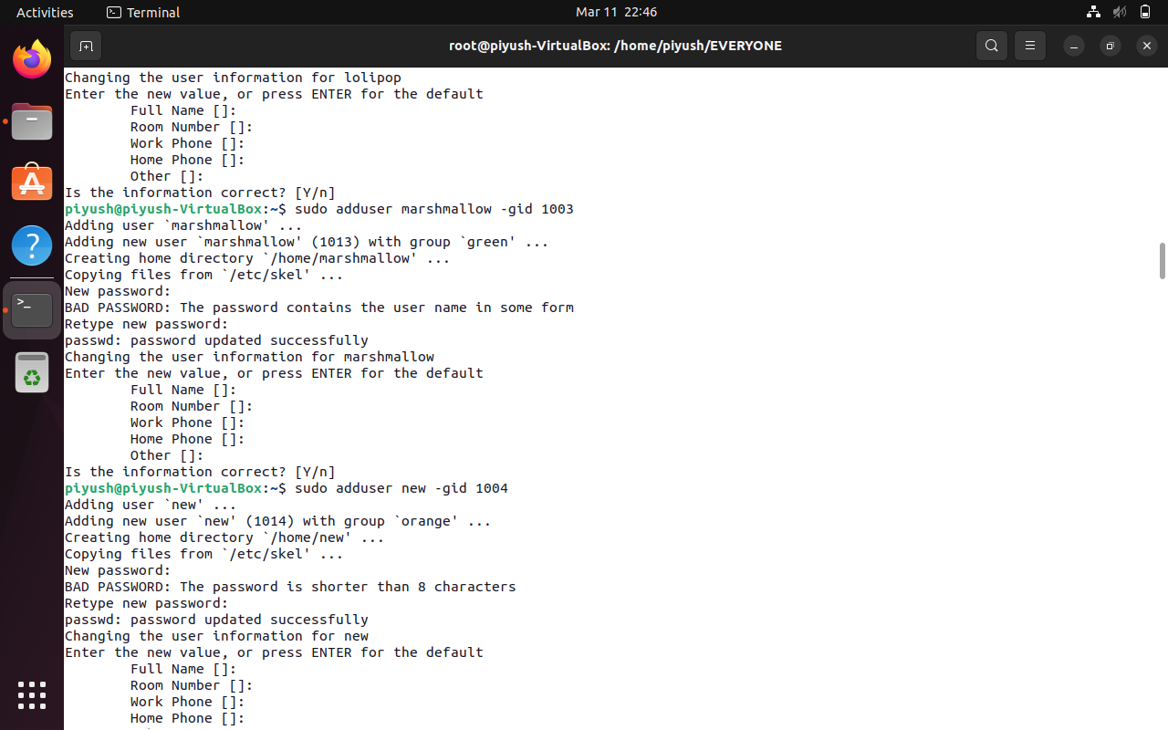

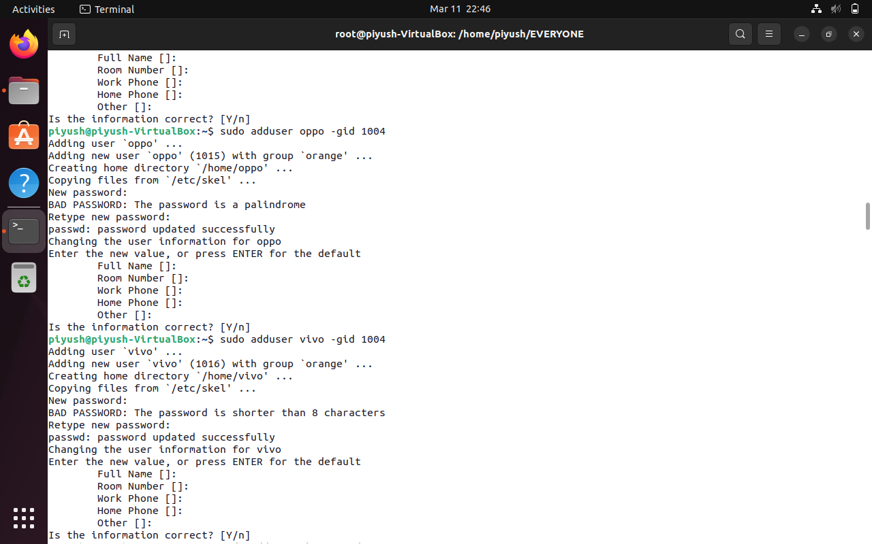

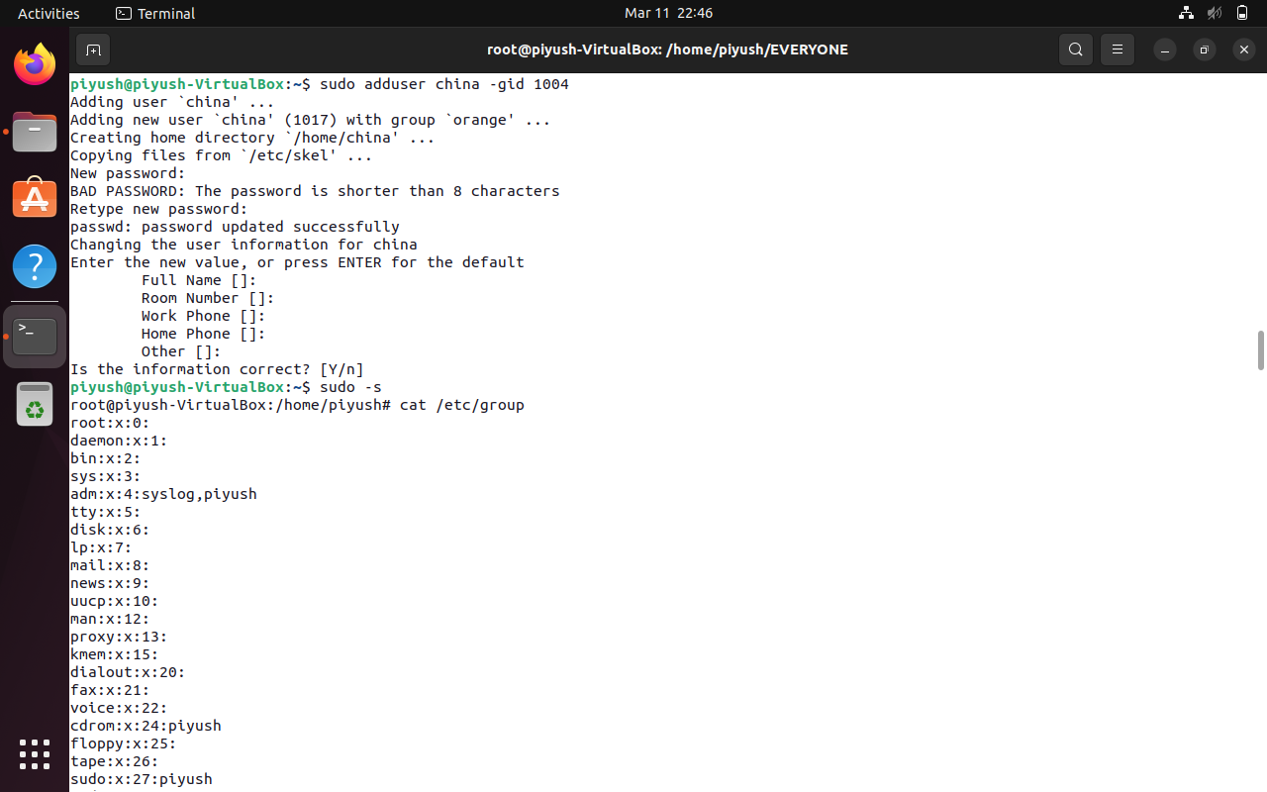

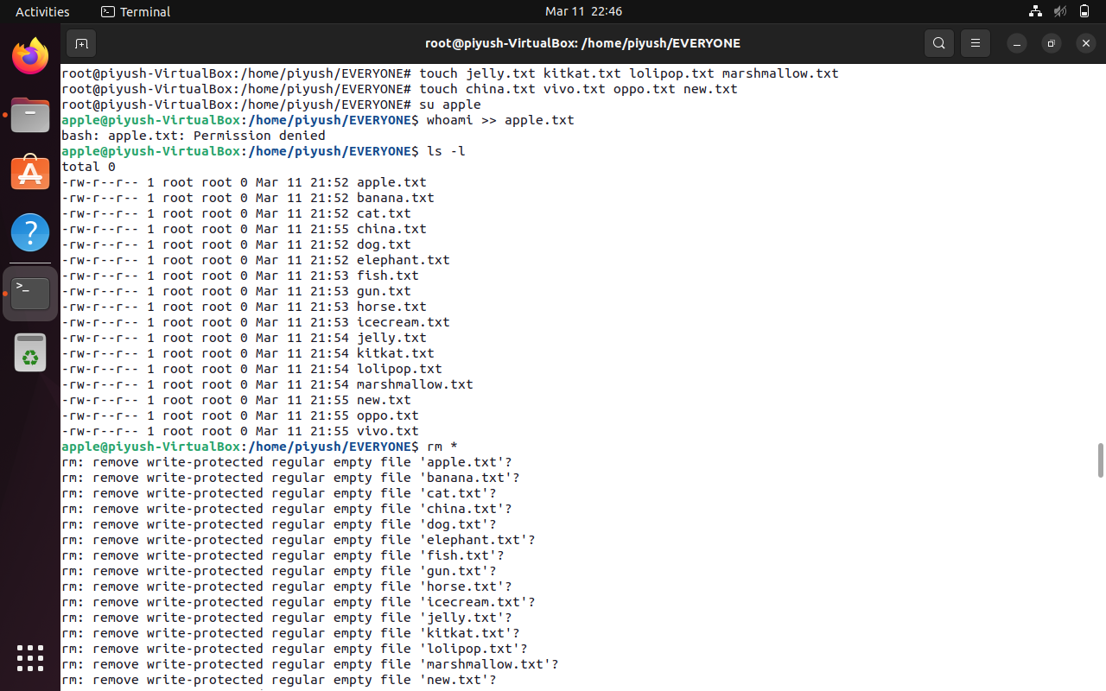

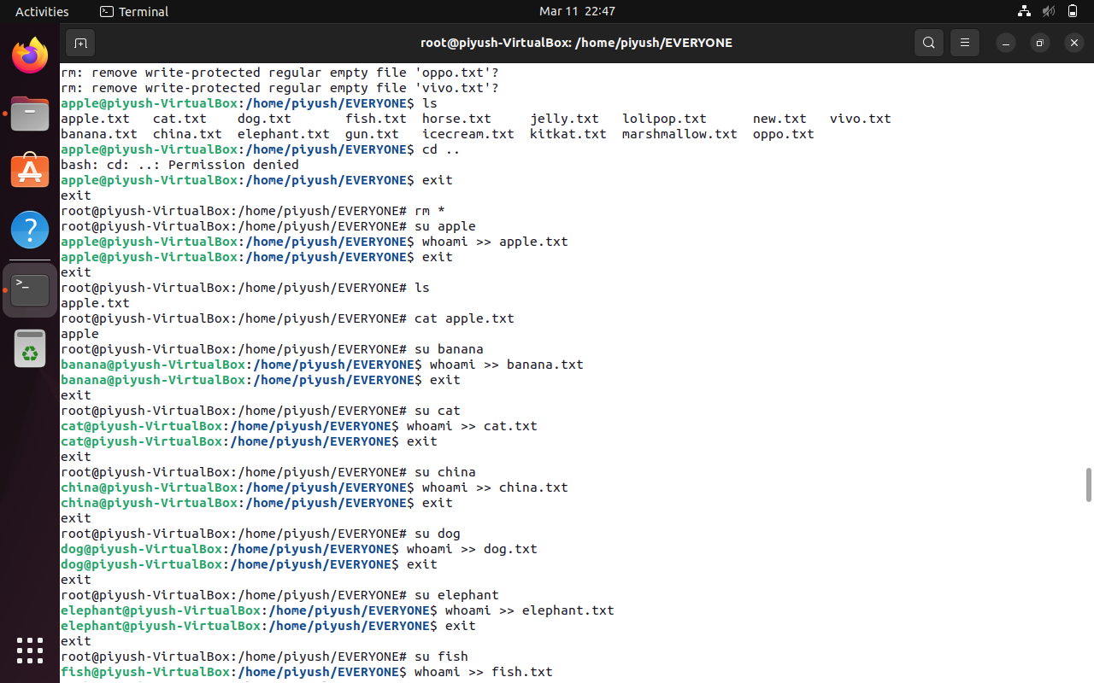

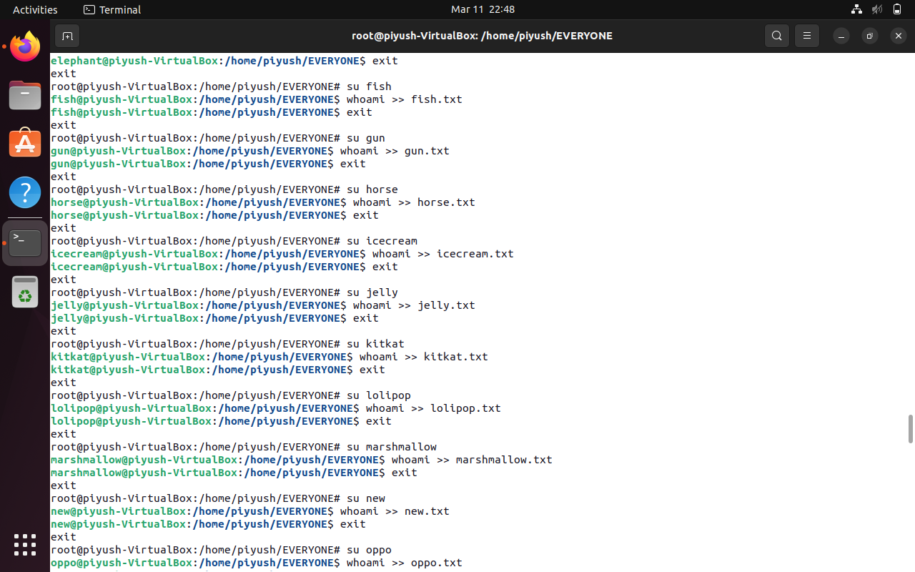

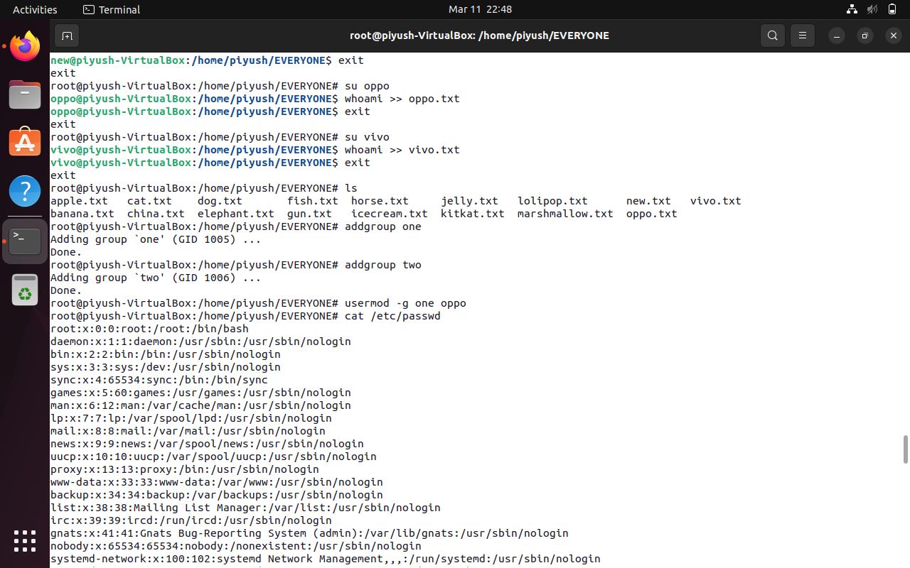

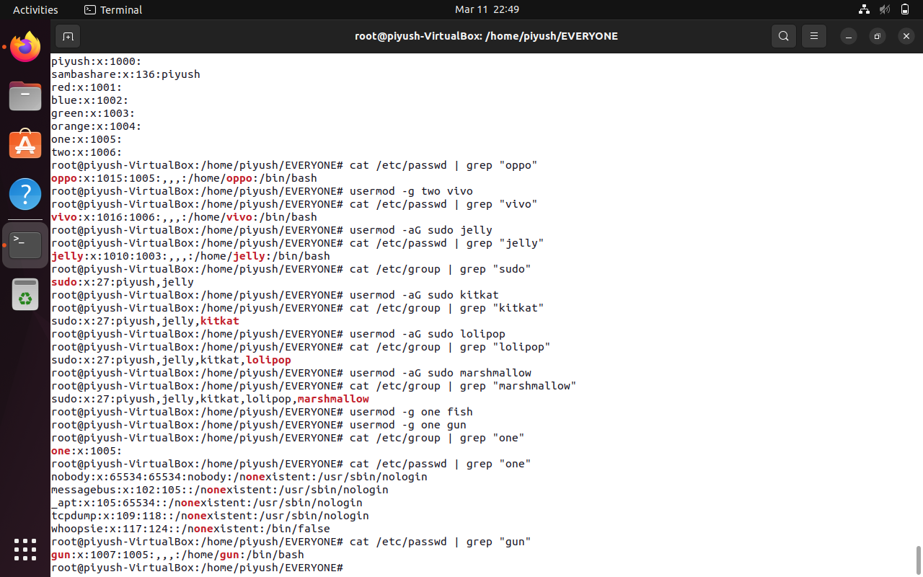

Q.2 Create Numbers.txt which will contain numbers from 1-50

a. display first 15 numbers

b. display last 10 numbers

c. display numbers in reverse order.

d.display numbers which includes 4 in it

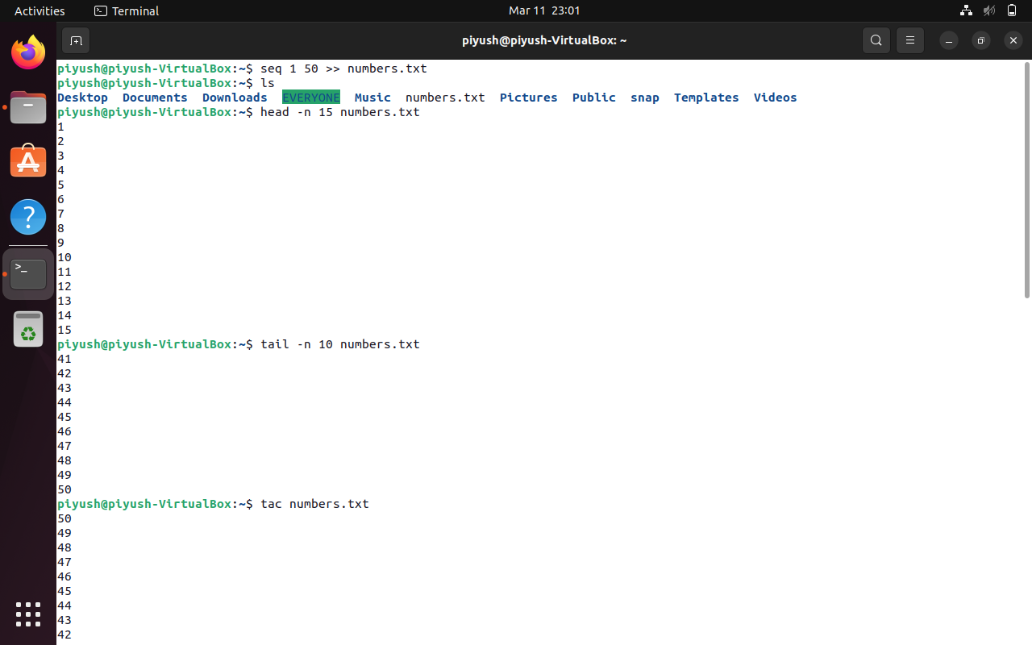

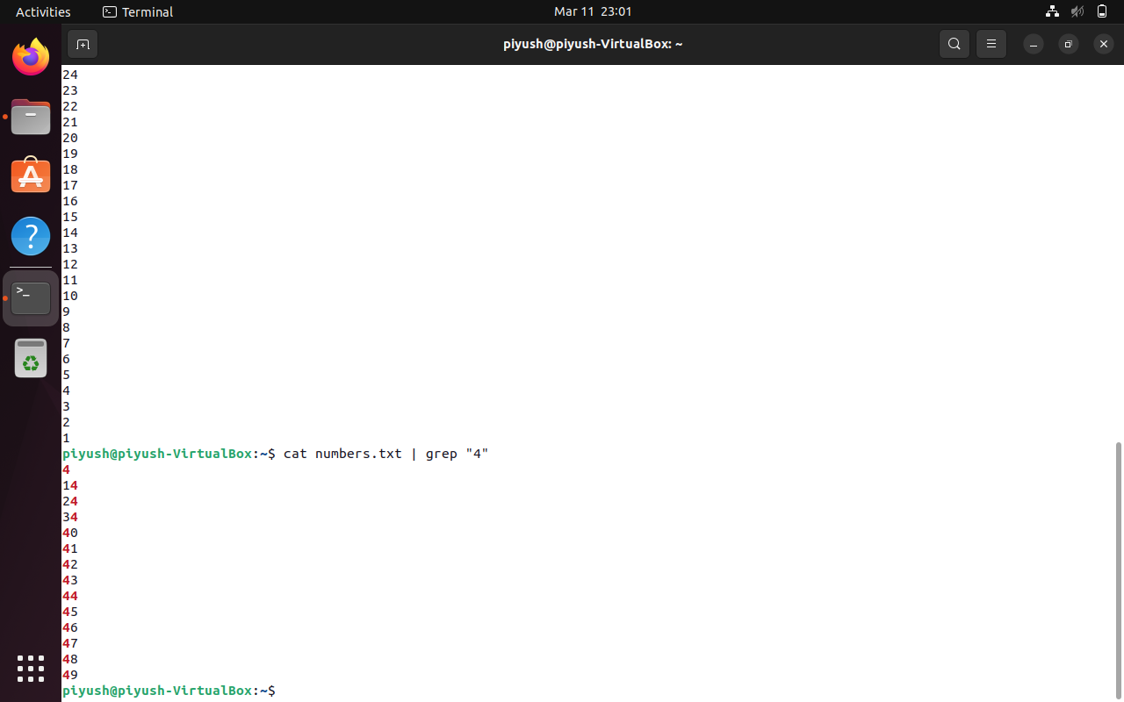

Q.3 create Student.txt file as given below

Rollno:name:marks

1111:Ram:87

2222:Sham:69

3333:Teena:58

4444:Priya:74

1. Display only details of sham
2. Display only marks of Priya
3. Display total number of lines in student.txt

